Automatic News Text Classification Using Natural Language Processing

Jagad A. Kalimosdo¹, Myat M. Thu², Dede D. A. Nugraha³, Naufal R. Pinugrohp⁴
¹Department of Informatics, Faculty of Computer Science, President University, Cikarang Utara
²Department of Information System, Faculty of Computer Science, President University, Cikarang Utara
³Department of Informatics, Faculty of Computer Science, President University, Cikarang Utara
⁴Department of Informatics, Faculty of Computer Science, President University, Cikarang Utara

¹jagad.kalimosodo@student.presindent.ac.id, ²myat.thu@student.president.ac.id,
³ dede.nugraha@student.president.ac.id, ⁴ naufal.pinugroho@student.president.ac.id.

Keywords: |  | ABSTRACT
Natural language processing  Text classification  Support vector machine  Long Short-Term Memory (LSTM)  News categorization |  | This study presents the development of an end-to-end Natural Language Processing (NLP) system for automatic classification of English news text. The objective of the research is to categorize news content into five predefined classes, namely Economy, Entertainment, Health, Politics, and Sport, to support efficient content organization and retrieval. A balanced dataset consisting of 25,385 news articles was used, with textual information derived from headlines and short descriptions. The data were preprocessed using standard NLP techniques, including case folding, noise removal, tokenization, and stopword elimination. Two classification approaches were implemented: a traditional machine learning model using Term Frequency–Inverse Document Frequency (TF-IDF) feature extraction combined with a linear Support Vector Machine (SVM), and a deep learning model based on Long Short-Term Memory (LSTM) networks. The SVM model was trained and evaluated using an 80:20 train–test split and achieved an overall accuracy of 84.32%. To demonstrate practical applicability, both models were integrated into a web-based application developed using a Flask backend and a Next.js frontend, enabling real-time classification of text, PDF documents, and audio inputs. Users are able to select between machine learning and deep learning methods during submission, providing a flexible and comparative news classification system.

- INTRODUCTION
The rapid expansion of online news platforms has resulted in a substantial increase in the volume of textual information produced on a daily basis. News content covers a wide range of domains, including economy, politics, health, sports, and entertainment, making manual categorization inefficient, time-consuming, and prone to inconsistency. As a result, automatic news text classification has become an essential task for improving information retrieval, content organization, and recommendation systems in digital media environments [1].
Natural Language Processing (NLP) enables computers to analyze, interpret, and extract meaningful patterns from unstructured textual data. In recent years, machine learning-based NLP techniques have demonstrated strong effectiveness in text classification tasks, particularly when combined with appropriate feature extraction methods. One of the most widely used techniques is Term Frequency–Inverse Document Frequency (TF-IDF), which represents text numerically by measuring the importance of terms within a document relative to the entire corpus. TF-IDF has been shown to provide a compact and informative representation of textual features for news classification tasks [2].
Support Vector Machine (SVM) classifiers have achieved reliable performance in high-dimensional text classification problems. Linear SVM models are especially effective for sparse feature spaces generated by TF-IDF vectorization, offering strong generalization capability and computational efficiency. Previous studies have shown that SVM remains competitive for news categorization tasks, particularly in applications that require fast inference, interpretability, and stable performance [3].
In addition to traditional machine learning approaches, deep learning methods have gained increasing attention for text classification due to their ability to automatically learn semantic and contextual representations from sequential data. Long Short-Term Memory (LSTM) networks, a type of recurrent neural network, are specifically designed to capture long-term dependencies in text sequences and have been successfully applied to various natural language processing tasks [6], [13]. These models are particularly effective for handling complex sentence structures and preserving word order information.
Despite the effectiveness of existing classification techniques, several limitations remain in current research. Many news classification systems focus solely on plain text input and do not support multiple data formats such as PDF documents or audio content. Furthermore, numerous studies emphasize model accuracy without integrating the classification model into a practical, user-accessible system, which limits real-world applicability and usability [4].
To address these challenges, this research proposes an end-to-end NLP-based news classification system that integrates both machine learning and deep learning approaches within a single framework. The proposed system employs TF-IDF feature extraction combined with a linear SVM as the machine learning model and an LSTM-based neural network as the deep learning model. Both models are deployed in a web-based application that supports real-time classification of text, PDF, and audio inputs. Users are able to select between machine learning and deep learning methods during classification, enabling flexible usage and comparative evaluation of different NLP techniques in practical news categorization scenarios.
- METHOD

  - Dataset and Data Preparation
The dataset used in this study consists of 25,385 English news records collected from a publicly available source. Each record contains a headline, a short description, and a category label. The headline and short description fields were combined into a single textual feature to enrich contextual information for classification. The dataset is balanced across five categories: Economy, Entertainment, Health, Politics, and Sport. To evaluate model performance objectively, the dataset was divided into 80% training data and 20% testing data using a stratified split to preserve class distribution [1].

  - Text Preprocessing
Text preprocessing was applied to transform raw textual data into a clean and standardized format suitable for machine learning and deep learning models. The preprocessing pipeline includes case folding to convert all characters to lowercase, removal of URLs, numerical values, and punctuation, tokenization of text into individual words, and elimination of stopwords using the NLTK English stopword list. Figure 1 presents an example of raw news text and its cleaned representation after the preprocessing stage. These steps reduce noise and dimensionality while preserving meaningful linguistic information relevant to classification [4].
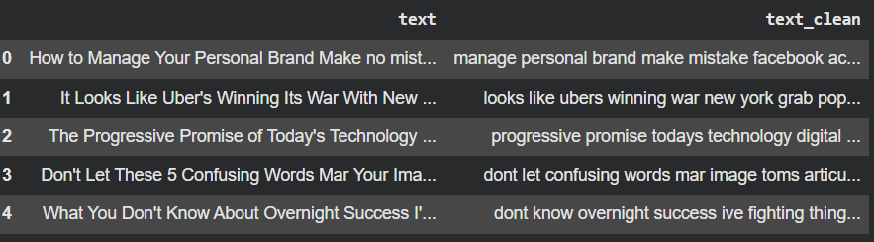

Figure 1. Output of text preprocessing

  - Feature Extraction
After preprocessing, the textual data were transformed into numerical feature vectors using the Term Frequency–Inverse Document Frequency (TF-IDF) method. TF-IDF evaluates the importance of a term within a document relative to the entire corpus by combining local term frequency with global inverse document frequency. This representation emphasizes informative words while reducing the influence of commonly occurring terms. In this study, unigram and bigram features were employed to capture both individual word significance and limited contextual information. To control dimensionality and improve computational efficiency, the feature space was limited to the top 10,000 features [2], [3].
The TF-IDF weighting scheme consists of term frequency (TF), inverse document frequency (IDF), and their combined weight, which are defined as follows:

$$TF = \frac{number of times the term appears in the document}{total number of terms in the document} (1)$$
$IDF = log(\frac{number of the document in the corpus}{number of documents in the corpus contain the term})$ (2)
TF-IDF = TF x IDF (3)

  - Tokenization and Sequence Representation for Deep Learning
For the deep learning approach, feature extraction was performed using a tokenization process instead of TF-IDF. The preprocessed text was converted into sequences of integers using a Keras tokenizer, where each word was assigned a unique index based on its frequency in the dataset. To ensure uniform input length for the neural network, all sequences were padded to a fixed maximum length. As an illustration of numerical text representation, Figure 2 presents an example of one-hot encoding, where each word is represented as a unique binary vector. This numerical representation preserves word order and enables further processing by sequence-based deep learning models such as Long Short-Term Memory (LSTM) networks [6], [13].

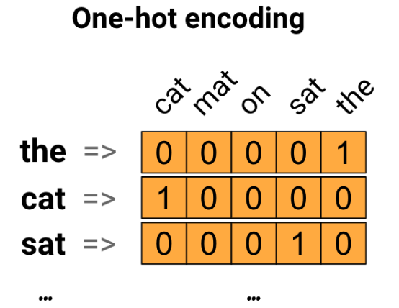

Figure 2. Example of one-hot encoding representation of words

  - Classification Mode
Support Vector Machine (Machine Learning)

A Support Vector Machine (SVM) classifier with a linear kernel was employed as the machine learning model. Figure 3 illustrates the fundamental concept of SVM, where an optimal hyperplane is constructed to maximize the margin between different classes using support vectors. Linear SVMs are particularly effective for high-dimensional text classification tasks generated by TF-IDF vectorization. The model was trained using the vectorized training dataset to learn decision boundaries that separate the five news categories. During inference, unseen text samples were transformed using the same TF-IDF vectorizer and classified based on the learned model parameters [3].

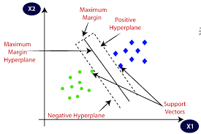

Figure 3. Conceptual representation of Support Vector Machine (SVM) with maximum margin hyperplane

Long Short-Term Memory (Deep Learning)

A Long Short-Term Memory (LSTM) neural network was implemented as the deep learning classifier. The internal structure of an LSTM cell is illustrated in Figure 4. The model architecture consists of an embedding layer that transforms word indices into dense vector representations, followed by an LSTM layer that captures sequential and contextual dependencies within the text. A dropout layer was applied to reduce overfitting, and a dense output layer with softmax activation was used to perform multi-class classification. The model was trained using the Adam optimizer and categorical cross-entropy loss function, with accuracy used as the primary evaluation metric [6].
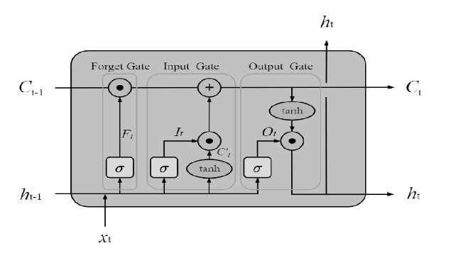

Figure 4. Internal structure of a Long Short-Term Memory (LSTM) cell

  - System Implementation
The proposed news classification system was implemented as a web-based application designed to support real-time processing and classification of news content from multiple input formats. The system architecture follows a client–server model, consisting of a frontend interface for user interaction and a backend service responsible for data processing, model inference, and result generation.
The frontend was developed using Next.js and provides users with multiple input options, including direct text entry, PDF file uploads, audio file uploads, and text document files. Users are also able to select the preferred classification approach, either machine learning or deep learning, prior to submitting the input. This selection determines the processing pipeline applied by the backend during inference.
The backend was implemented using the Flask framework and handles all computational tasks. Uploaded PDF files are processed using the PyPDF2 library to extract textual content, while audio files are converted into text using a speech recognition module. Text files are read directly by the system. Regardless of the input format, all extracted text is passed through a unified preprocessing pipeline that includes case folding, removal of URLs and numerical values, punctuation removal, tokenization, and stopword elimination using the NLTK library [4].
After preprocessing, the system routes the text to the appropriate classification pipeline based on the user’s selection. For the machine learning approach, the text is transformed into numerical features using a pre-trained TF-IDF vectorizer and classified using a linear Support Vector Machine (SVM) model. For the deep learning approach, the text is converted into integer sequences using a Keras tokenizer, padded to a fixed length, and classified using a trained Long Short-Term Memory (LSTM) neural network.
In parallel with the classification process, the system performs Named Entity Recognition (NER) to extract relevant entities from the processed text. The NER module is implemented using the spaCy library and identifies named entities such as persons, organizations, and locations [10]. Finally, the system generates a structured response containing the predicted news category, classification confidence, and extracted named entities. The results are returned to the frontend in JSON format and displayed to the user through the web interface. The overall workflow of the system is illustrated in Figure 5.

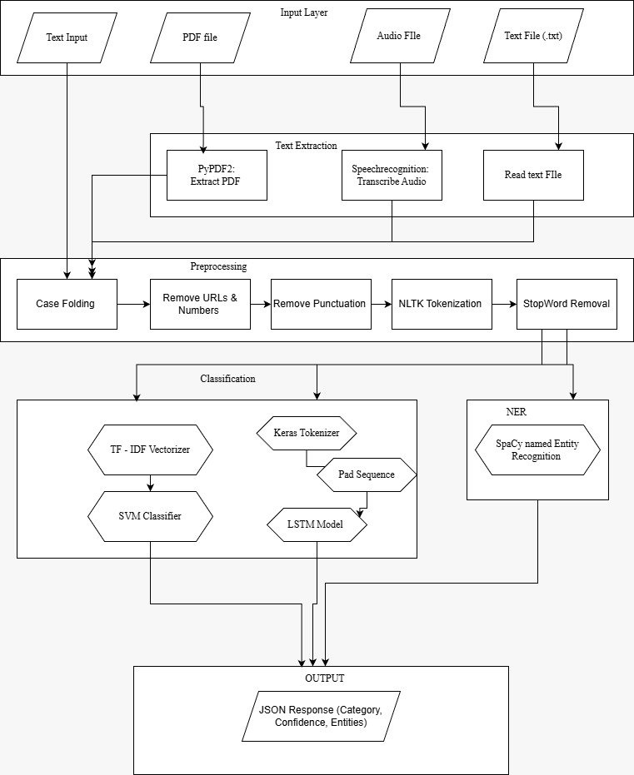

Figure 5. System flowchart of the proposed news classification framework

- RESULTS AND DISCUSSION

  - Machine Learning Result
The performance of the machine learning model was evaluated using a testing dataset consisting of 5,077 news articles. The Support Vector Machine (SVM) classifier combined with TF-IDF feature extraction achieved an overall accuracy of 84.32%, indicating strong classification performance across the five news categories. Detailed evaluation metrics, including precision, recall, and F1-score for each class, are presented in Figure 6. The results show balanced performance among categories, with the Sport category achieving the highest F1-score, while Economy exhibits relatively lower but stable performance.
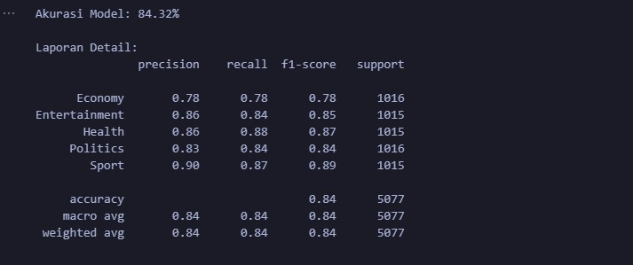

Figure 6. SVM classification report

To further analyze classification behavior, a confusion matrix was generated as shown in Figure 7. The confusion matrix illustrates that most predictions fall along the diagonal, indicating correct classification across categories. Misclassifications primarily occur between semantically related categories such as Economy and Politics, which is expected due to overlapping vocabulary in news content. Overall, the SVM model demonstrates strong generalization ability and low bias, supported by the high-dimensional TF-IDF representation using unigram and bigram features.
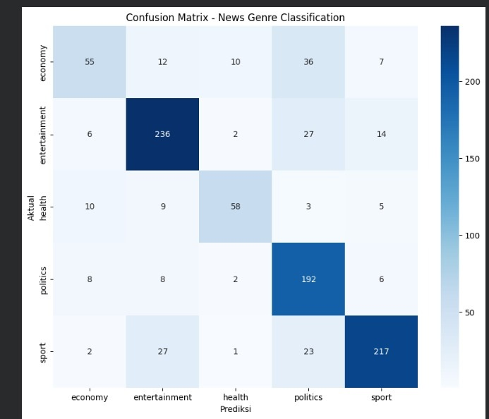

Figure 7. Confusion matrix of the SVM classifier
In addition, multiple SVM kernels were evaluated to determine the most suitable configuration. As shown in Figure 8, the linear kernel achieved the highest accuracy compared to radial basis function (RBF), polynomial, and sigmoid kernels. This result confirms that linear SVM is well suited for sparse and high-dimensional text data, and therefore was selected as the final machine learning model for system deployment.
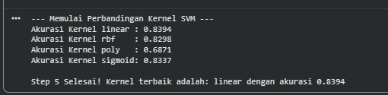

Figure 8. SVM kernel comparison

  - Deep Learning Result
The deep learning approach using a Long Short-Term Memory (LSTM) network was evaluated using the same testing dataset. The training and validation performance of the LSTM model across multiple epochs is illustrated in Figure 9. The results show a steady increase in training and validation accuracy accompanied by a consistent reduction in loss values, indicating effective learning and convergence of the model.
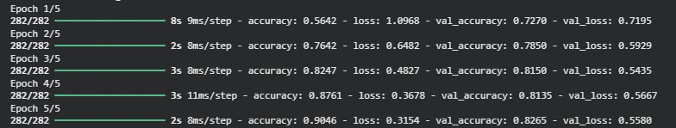
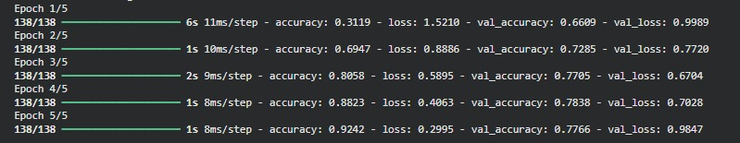
The LSTM model demonstrated competitive classification performance, particularly for news articles containing longer sentences and more complex contextual structures. By preserving word order and learning sequential dependencies, the model is able to capture semantic relationships that are not explicitly represented by TF-IDF features. Although the deep learning model requires higher computational resources and longer training time compared to the SVM approach, it provides a robust alternative for deep semantic text analysis in news classification tasks.

Figure 9. LSTM training curves

  - System Implementation Result
The trained machine learning and deep learning models were successfully deployed in a web-based application to demonstrate real-time usability. The system allows users to input text directly or upload PDF and audio files for automatic news classification. Users can also select the preferred classification method, either machine learning (SVM) or deep learning (LSTM), prior to submission.
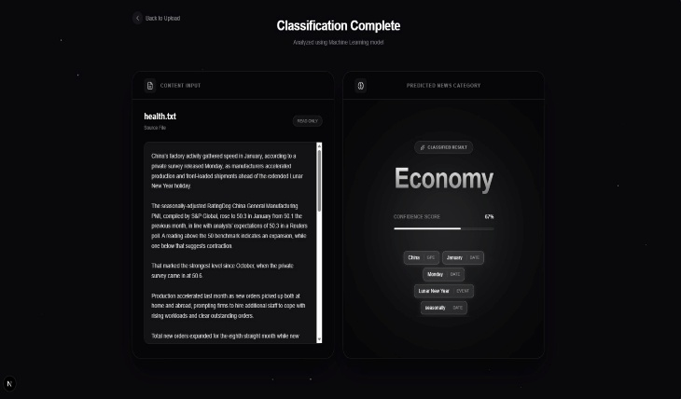
Figure 10 presents the main interface of the proposed system along with an example of classification output. The results show that the system is able to process user input efficiently and return predicted news categories in real time. This implementation confirms the practicality of the proposed approach and demonstrates the integration of NLP models into an accessible and interactive application.
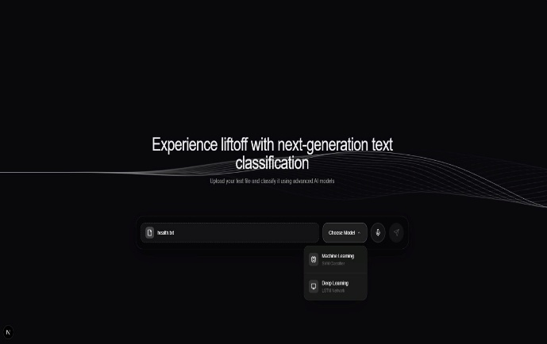
Figure 10. Web-based news classification system interface showing input options and classification results

Discussion
The experimental results demonstrate that both machine learning and deep learning approaches are effective for automatic news text classification, with each method offering distinct advantages. The SVM model achieved high classification accuracy while maintaining relatively low computational cost, making it efficient and well suited for real-time deployment in web-based applications. This result confirms that traditional machine learning techniques remain highly effective when combined with appropriate feature extraction methods such as TF-IDF.

In contrast, the LSTM-based deep learning model exhibits enhanced capability in capturing contextual and sequential information within textual data. This characteristic makes it particularly suitable for complex or lengthy news articles where word order and long-term dependencies play an important role. However, this improved contextual understanding is accompanied by increased training complexity and computational requirements compared to the machine learning approach.

By integrating both SVM and LSTM models into a single web-based system and allowing users to select the preferred classification method, the proposed system provides flexibility and supports comparative evaluation of different NLP techniques. This dual-model design highlights the trade-offs between efficiency and contextual modeling, offering practical insights for selecting appropriate classification approaches in real-world news categorization scenarios.

- CONCLUSION
This study presents an end-to-end Natural Language Processing (NLP) system for automatic classification of English news text into five categories: Economy, Entertainment, Health, Politics, and Sport. The proposed system integrates both traditional machine learning and deep learning techniques to address the challenges of large-scale news categorization. Experimental results show that a linear Support Vector Machine (SVM) combined with TF-IDF feature extraction achieves strong performance, with an overall accuracy of 84.32%, while maintaining computational efficiency suitable for real-time applications.
In addition to the machine learning approach, a Long Short-Term Memory (LSTM) deep learning model was implemented to capture sequential and contextual information within textual data. The LSTM model provides an effective alternative classification strategy, particularly for more complex or longer text inputs, although it requires higher computational resources during training.
Both classification models were successfully deployed within a web-based application that supports real-time classification of text, PDF documents, and audio inputs. The ability for users to select between machine learning and deep learning methods enhances system flexibility and enables comparative evaluation of different NLP techniques in practical settings. Overall, the results demonstrate that the proposed system is effective, adaptable, and suitable for real-world automated news text classification applications.

REFERENCES

[1] A. Joulin, E. Grave, P. Bojanowski, and T. Mikolov, “Bag of tricks for efficient text classification,” Proceedings of the European Chapter of the Association for Computational Linguistics, pp. 427–431, 2017.
[2] G. Salton and C. Buckley, “Term-weighting approaches in automatic text retrieval,” Information Processing & Management, vol. 24, no. 5, pp. 513–523, 1988.
[3] T. Joachims, “Text categorization with support vector machines: Learning with many relevant features,” Proceedings of the European Conference on Machine Learning, pp. 137–142, 1998.
[4] S. Bird, E. Klein, and E. Loper, Natural Language Processing with Python. Sebastopol, CA, USA: O’Reilly Media, 2009.
[5] Y. Kim, “Convolutional neural networks for sentence classification,” Proceedings of the 2014 Conference on Empirical Methods in Natural Language Processing (EMNLP), pp. 1746–1751, 2014.
[6] S. Hochreiter and J. Schmidhuber, “Long short-term memory,” Neural Computation, vol. 9, no. 8, pp. 1735–1780, 1997.
[7] J. Pennington, R. Socher, and C. Manning, “GloVe: Global vectors for word representation,” Proceedings of the 2014 Conference on Empirical Methods in Natural Language Processing (EMNLP), pp. 1532–1543, 2014.
[8] C. D. Manning, H. Schütze, and P. Raghavan, Introduction to Information Retrieval. Cambridge, UK: Cambridge University Press, 2008.
[9] M. Peters et al., “Deep contextualized word representations,” Proceedings of the 2018 Conference of the North American Chapter of the Association for Computational Linguistics, pp. 2227–2237, 2018.
[10] M. Honnibal and I. Montani, “spaCy 2: Natural language understanding with Bloom embeddings, convolutional neural networks and incremental parsing,” To appear, 2017.
[11] D. Jurafsky and J. H. Martin, Speech and Language Processing, 2nd ed. Upper Saddle River, NJ, USA: Prentice Hall, 2009.
[12] K. Murphy, Machine Learning: A Probabilistic Perspective. Cambridge, MA, USA: MIT Press, 2012.
[13] I. Goodfellow, Y. Bengio, and A. Courville, Deep Learning. Cambridge, MA, USA: MIT Press, 2016.

